*Analyzes Microsoft’s role in the Fourth Industrial Revolution*

**Assignment**

**4**

A4

ALY6060 Decision Support & Business Intelligence

Assignment 4 – Implementing Embedded Analytics

**PREPERATION:**

By: John DiSessa

For: Professor Ellis

On: June 19th, 2022

Introduction

Microsoft has been a leader in the digital transformation of our society since they first released Windows in 1985. The Fourth Industrial Revolution is yet another example of Microsoft changing the world. While many companies struggle to adapt to Industry 4.0, Microsoft has been providing real-world Artificial Intelligence applications that capitalize on the interconnectivity of data and people. Part One of this report analyzes how Microsoft is impacting Industry 4.0 and gives recommendations for how they can improve their implementation of business intelligence tools. Part Two of this report analyzes data from reported errors and failures with their most important Industry 4.0 application, Azure, and presents it in an interactive Tableau dashboard.

Part One

“Industry 4.0 refers to a new phase in the Industrial Revolution that focuses heavily on interconnectivity, automation, machine learning, and real-time data.” Many companies are forced to adapt to these changes or else operate at a disadvantage to companies who can offer technologically advanced products or be able to interpret and make decisions based on real-time big data. Rather than being affected by the changes Industry 4.0 creates, Microsoft is at the forefront of Industry 4.0 and are dictating the changes themselves. Unlike many companies who use interconnectivity and real-time data to make decisions for their own advantages, Microsoft is providing real world applications that make the everyday lives of people better. For example, they have Windows Hello which uses facial recognition to replace passwords. “… if you use Word, if you use PowerPoint, if you use Excel, they have a suggestion function for all of those. For PowerPoint, it suggests ways to put your slides together. For Excel, it suggests formula as you might use based on the context of what's around you. All of that is driven by their artificial intelligence engine.” Their AI “helps to match searches with useful results, and gives the Cortana virtual assistant the ability to improve and become more helpful over time. Through Skype, it enables chatbots to run on its communications platform, where they can be used for customer services or accessing services such as weather or travel information. Within its Office enterprise productivity suite, as well as assistance from Cortana, Microsoft has been rolling out AI-assisted features designed to offer help with everyday tasks, such as live translation of recorded speech.” Microsoft is uniquely positioned where they can leverage all of their products and subsidiaries. Their whole suite together is greater than the sum of their parts. Also, they have taken a unique approach to machine learning by not relying entirely on coders. They hire people that are experts in various fields to teach their machines how to do things they do in order to be more human-like.

Even though Microsoft is at the forefront of Industry 4.0 for their own service offerings, they also give the general public access to AI, machine learning, cloud computing, analytics, security, development, etc. all in one service for people to use for personal or professional use cases. With Microsoft Azure, Microsoft is truly shaping the industry. “Now, with machine learning available on the Azure cloud, developers can build learning capabilities into their own applications: recommendations, sentiment analysis, fraud detection, fault prediction, and more. The idea of the new Azure offering is to democratize machine learning, so you no longer need to hire someone with a doctorate to use a machine learning algorithm.” In previous industrial revolutions, the technology has been capable of significantly reducing poverty and income inequality by making it cheaper to mass produce better goods and services. However, because of an inequal distribution of those benefits, we still have cases of extreme poverty and worsening income inequality. Microsoft has “the opportunity to proactively shape the Fourth Industrial Revolution to be both inclusive and human-centered. This revolution is about much more than technology—it is an opportunity to unite global communities, to build sustainable economies, to adapt and modernize governance models, to reduce material and social inequalities, and to commit to values-based leadership of emerging technologies.” While Microsoft does not have a financial obligation to sacrifice corporate profits for the greater good of society, I believe they have an ethical obligation to do so as a multi-billion-dollar conglomerate. Since they offer this service to everyone at fair prices for their different Azure tiers, I think they are on their way to fulfilling their ethical obligation. However, we are still a long way away and they will need to monitor their strategic objectives closely.

Based on our research, we recommend Microsoft differentiate between signals and noise in their products and services as well as focus on micro-societal-improvements as opposed to being revolutionary. These recommendations will improve their implementation of business intelligence tools for all of their departments. The more data that is available for companies to make decisions results a higher chance of some of that data being misinterpreted. It is incumbent on industry-leading companies like Microsoft to identify useful, accurate, and honest data and interpretations. With the Covid-19 pandemic, our society had enough data to understand Covid’s impacts and thus take actions to save millions of lives. However, “the global flood of misinformation enabled by these platforms is making it more difficult to manage the Covid-19 pandemic and tackle climate change. Few realized what was happening until it was too late, and now we are dealing with the fallout.” Fake news, misinformation, and a lack of data awareness led to sub-optimal decision making. Our second recommendation for Microsoft is to focus on micro-improvements first to slowly build knowledge, acceptance, and trust of Industry 4.0. Going all-in on one aspect too quickly increases the likelihood of catastrophic failure. If Microsoft focuses their Industry 4.0 objectives towards one area, that strategy would blow up in their faces if their sole project fails. This would damage their reputation as well as hurt Industry 4.0’s progress since Microsoft has such a strong public impact. If they make many small improvements to various parts of society, they can learn more over time and affect change in more people without the risk of catastrophic failure.

Part Two

We combined datasets from Kaggle regarding 2015 data on Microsoft’s deliverability of Azure. In creating our Tableau dashboard, we combined datasets with different variables such as machine model type, error type, failure type, machine age, and dates of reported errors or failures. Our goal was to assess the reliability of Microsoft’s servers to see if certain variables affected error and failure rates.

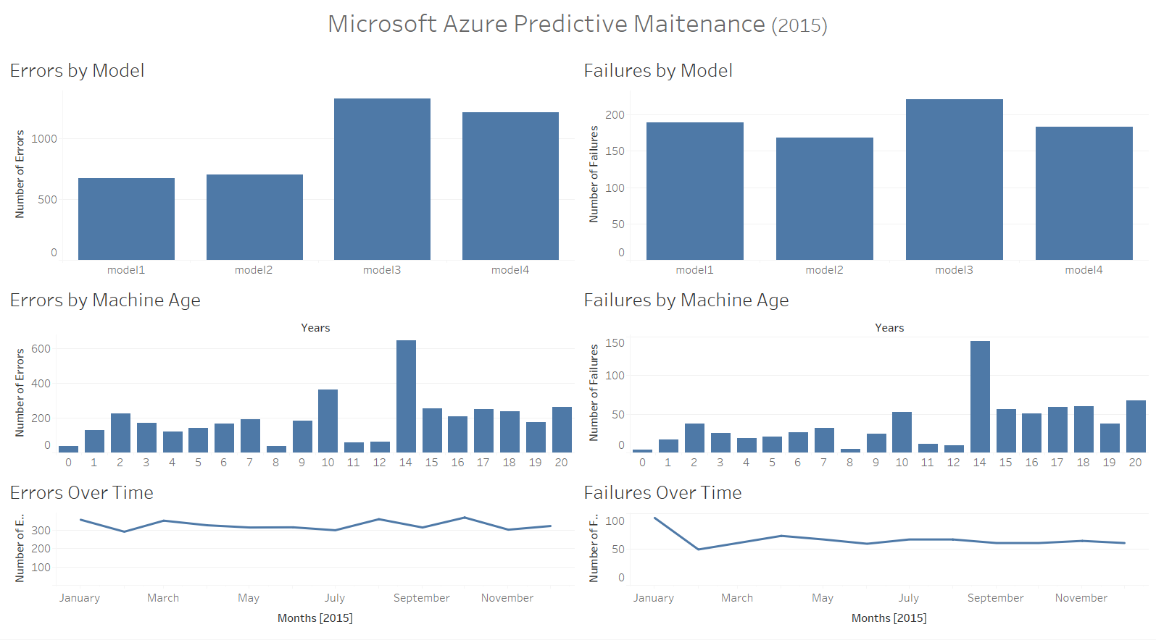

In addition to seeing the differences in performance from their various models and their various ages of machines, we were also able to compare the frequency of errors versus the frequency of system failures. Errors hurt Microsoft’s performance ratings; however, failures are significantly worse since those result in long term or permanent outages.

First, we looked at the errors and failures by model type. Model 1 had the fewest errors but the 2nd most failures. This is very concerning for anyone that was dependent on Model 1 because about 30% of their errors resulted in total failures whereas the other models were able to rebound from their errors and continue operations. Model 2, however, had the lowest number of failures and about the same number of errors, despite having the highest average age of almost 13 years. Models 3 and 4 had the most errors and failures despite having the youngest average ages of 12 years and 9.5 years respectively. Without having any other context clues, Model 2 is by far superior due to its ability to operate longer and with fewer errors and failures.

Machine Age also seems to have a significant impact on performance. I would have expected to see a linear up-trend with more errors and failures as machines got older. We partially see that trend with ages 15-20 all being significantly higher than ages 0-7, however age 8 has the lowest errors and failures and age 14 has the highest errors and failures which is counter intuitive. It is possible after 14 years they start to decommission many machines, but it is more likely that the dataset is not providing the entire picture.

Lastly, regarding errors and failures over time, it seems that Microsoft was not active in improving their Azure network. Errors and failure rates stayed constant all throughout 2015 across all models. Azure likely exceeded Microsoft’s sales expectations and therefore Microsoft was not prepared or ready to make significant improvements. They did not have enough quality models or enough service to meet the customer demand, which resulted in a lack of improvement in the Azure network. Azure has the potential to make Microsoft the biggest leader in Industry 4.0 and thus is worth an overhaul or significant investment boost.

Summary

Contrary to many companies who are struggling to grapple with the changes Industry 4.0 is having on the world, Microsoft is actually leading the world into artificial intelligence, machine learning, interconnectivity, and data-driven decision making. They are uniquely situated to impact the world and have ethical obligations to consider societal impacts as opposed to corporate profits. Azure is the first step into achieving global adoption of AI and data connectivity but it still has high error and failure rates. Microsoft needs to reinvest a significant amount of resources into Azure because it has the potential give society the benefits of Industry 4.0.

Citations

Arnab. “Microsoft Azure Predictive Maintenance.” *Kaggle*, 15 Oct. 2020, https://www.kaggle.com/datasets/arnabbiswas1/microsoft-azure-predictive-maintenance?select=PdM_machines.csv.

“Artificial Intelligence Research at Microsoft Aims to Enrich Our Experiences.” *Microsoft Research*, 10 June 2021, https://www.microsoft.com/en-us/research/research-area/artificial-intelligence/?facet%5Btax%5D%5Bmsr-research-area%5D%5B0%5D=13556&sort_by=most-recent.

Bigelow, Stephen J. “What Is Microsoft Azure and How Does It Work?” *SearchCloudComputing*, TechTarget, 6 Apr. 2020, https://www.techtarget.com/searchcloudcomputing/definition/Windows-Azure.

Bordelon, Trevor Jennewine and Toby. “Here's How Microsoft Is Using Artificial Intelligence.” *The Motley Fool*, The Motley Fool, 12 Oct. 2021, https://www.fool.com/investing/2021/10/12/heres-how-microsoft-using-artificial-intelligence/.

Branscombe, Mary. “What Is Microsoft Doing with Machine Learning?” *InfoWorld*, InfoWorld, 19 Feb. 2015, https://www.infoworld.com/article/2886132/how-machine-learning-ate-microsoft.html.

“The Fourth Industrial Revolution.” *Encyclopædia Britannica*, Encyclopædia Britannica, Inc., https://www.britannica.com/topic/The-Fourth-Industrial-Revolution-2119734.

Marr, Bernard. “The Amazing Ways Microsoft Uses AI to Drive Business Success.” *Forbes*, Forbes Magazine, 10 Oct. 2017, https://www.forbes.com/sites/bernardmarr/2017/10/02/the-amazing-ways-microsoft-uses-ai-to-drive-business-success/?sh=577f2765473b.

“Opinion: Will the Fourth Industrial Revolution Serve Sustainability?” *The Kathmandu Post*, The Kathmandu Post, https://kathmandupost.com/columns/2021/05/04/will-the-fourth-industrial-revolution-serve-sustainability.

“What Is Industry 4.0-the Industrial Internet of Things (IIOT)?” *What Is Industry 4.0? | The Industrial Internet of Things | Epicor U.S.*, https://www.epicor.com/en-us/blog/learn/what-is-industry-4-0/.

“What Is Industry 4.0?: Definition, Technologies, Benefits: SAP Insights.” *SAP*, https://www.sap.com/insights/what-is-industry-4-0.html.

Written by Klaus Schwab, Founder and Executive Chairman. “The Fourth Industrial Revolution: What It Means and How to Respond.” *World Economic Forum*, https://www.weforum.org/agenda/2016/01/the-fourth-industrial-revolution-what-it-means-and-how-to-respond/.